**Project Configuration**

**What is Project Menu?**

The Project menu provides commands that affect the project structure. It allows adding/editing new items, projects, or specifications of the project. Project Menu is intended to help the user in handling the projects developed as a single entity rather than as individual screens. Using the options in this project menu, a user can compile, run and install a project as a single unit.

**Prerequisites**

**An account with FireFlink**

*(To sign-up and purchase a license, please visit our official website at* [*https://www.fireflink.com/*](https://www.fireflink.com/) *if you do not have an account.)*

**A FireFlink project**

**Navigation**

**Project Selection > Projects Tab > Project Config**

**Note:** A breadcrumb or a breadcrumb trail is a graphical control element frequently used as a navigational aid in user interfaces and on web pages. It allows users to keep track and maintain awareness of their locations within programs, documents, or websites.

**Steps to navigate to Project Menu**

After logging into the platform, a dropdown menu will be visible in the left navigation bar under "**All Projects**".

By default, the "All Projects" option will be displayed in the dropdown menu. The user can then choose an "Individual Project" by selecting the name of the project from the options in the dropdown. Alternatively, users can click on the name of the project on the Project List page.

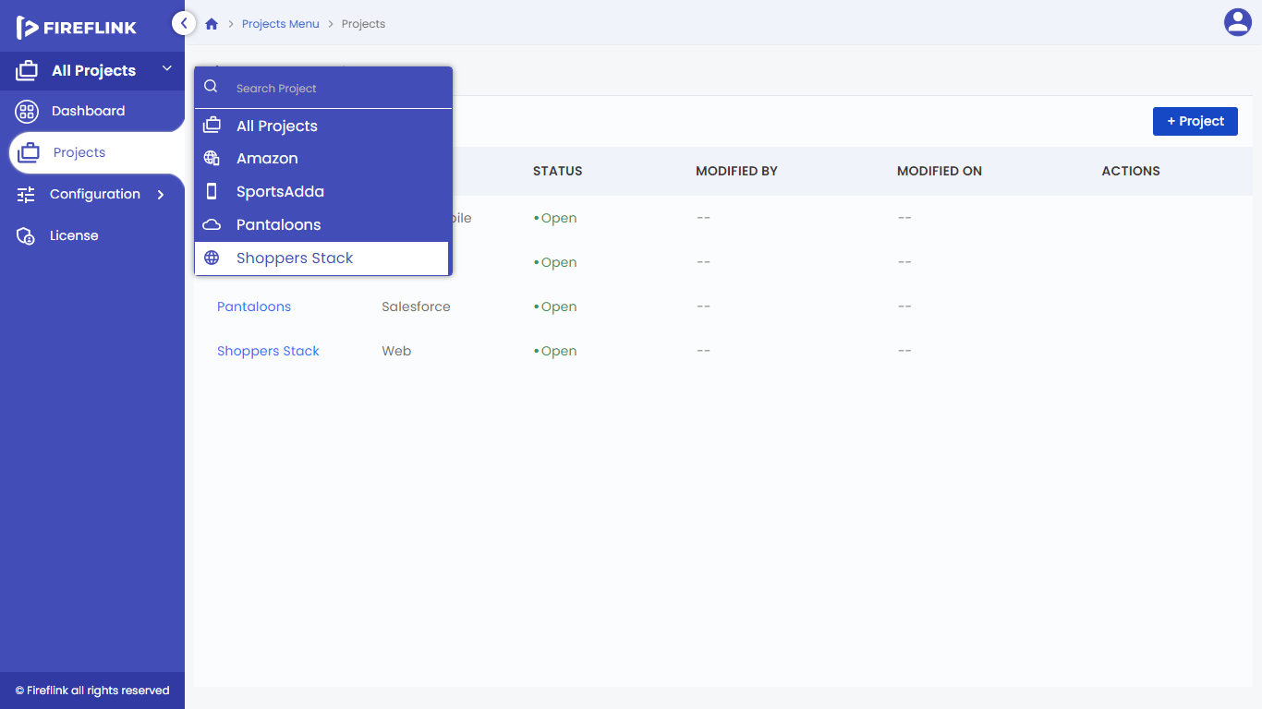

**Why do we need the "Individual Project" option?**

Users can utilize the detailed project view to edit the project details, add users, and assign roles to each user individually.

**Project Configuration Section**

Users can see the project details here. They can also edit the project details using the Edit button.

The Project Config section consists of all the data provided during the project creation, and It consists of the following:

1. **Name:** Name given to the Projects will be displayed.
2. **Type:** Type of the project created will be displayed.
3. **Description:** Description given to the project will be displayed.
4. **Status:** Status of the Projects (Open/Closed) will be displayed.
5. **Created by**: Name of the user who has created the project will be displayed.
6. **Created on:** Date and time on which the project created will be displayed.
7. **Modified by:** Name of the user who has modified the project will be displayed.
8. **Modified on:** date and time of modification done for the project will be displayed.
9. **File Names:** If the user has uploaded any APK or IPA files, it is displayed along with the name and download button. Upon clicking on the download icon, the file is downloaded onto the user's local machine.

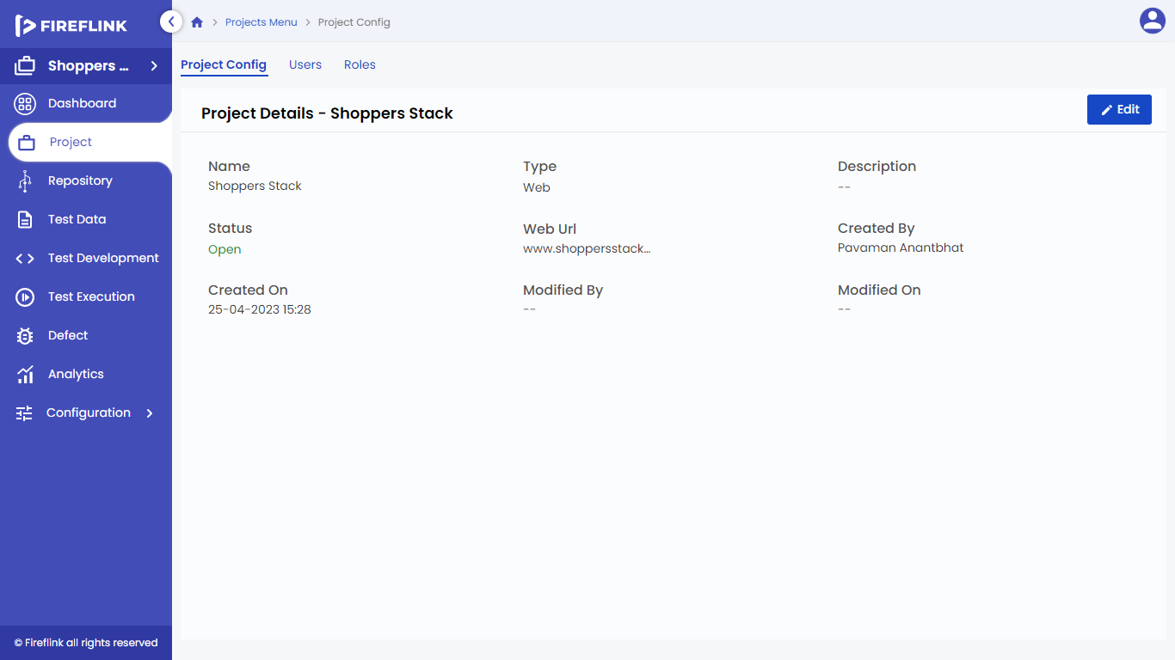

• **Edit** **Button**: Upon clicking on the Edit button, the user is allowed to edit the project details. All the fields here are editable except for the **Type and Platform fields**. Users can modify it according to their requirements and click on the update button to update changes. And the changes will be reflected in the Project Config screen.